|  |
| --- |
| LOCKEDME.COM  (Project Specification and Scrum Details) |

**VERSION HISTORY**

|  |  |
| --- | --- |
| AUTHOR | Deepali B. Sandimani |
| PURPOSE | Project Specification and Scrum Details |
| DATE | 12th Aug 2021 |
| VERSION | 1.0 |

The code for this project is hosted at: https://github.com/Deepa1725/LockedMe

**Table of Contents**

1. Sprint Planning and Task completion.
2. Core concepts used in project.
3. Demonstrating the application capabilities, appearance and user interactions.
4. Conclusions.
5. Sprint planning and Task Completion:

The project is planned to be completed in 1 sprint. Tasks assumed to be completed are:

* Creating the flow of application.
* Initializing git repository to track changes as development progresses.
* Writing the Java program to fulfil the requirements of the project.
* Testing the Java program with different kind of user input.
* Pushing the code to GitHub.
* Creating the specification document highlighting application capabilities, appearance and user interactions.

1. **Core concepts used in the Project:**

The different concepts used in this project includes:

* Collections framework
* File Handling
* Sorting
* Flow Control
* Exception Handling
* Stream APIs

**3. Demonstrating the application capabilities, appearance and user interactions:**

To demonstrate the product capabilities, below are the subsections configured to highlight appearance and user interactions for the project:

1. Creating the project in Eclipse.
2. Writing the program in Java for entry point of application, to display main menu

(LockedMe.java)

1. Writing a program in Java to perform File Operations as specified by the user

(FileManager.java).

1. Pushing the code to GitHub repository.

**LockedMe.Java:**

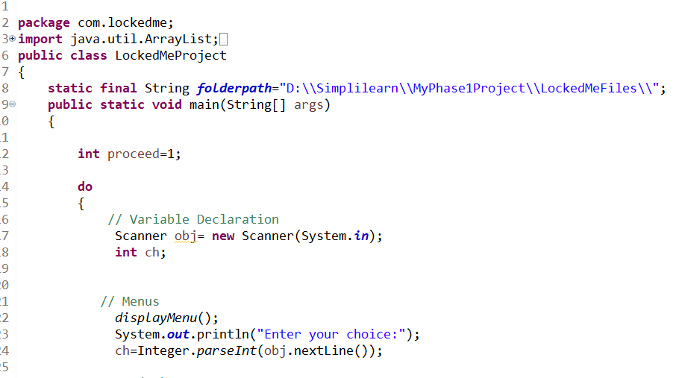

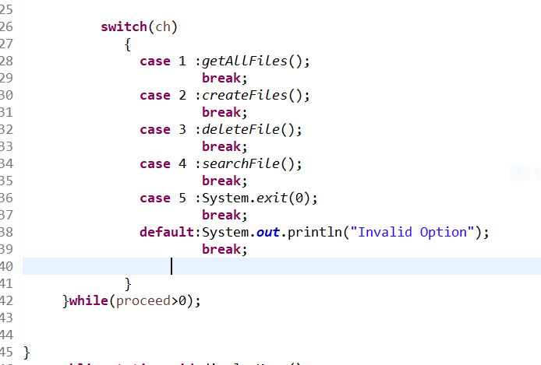

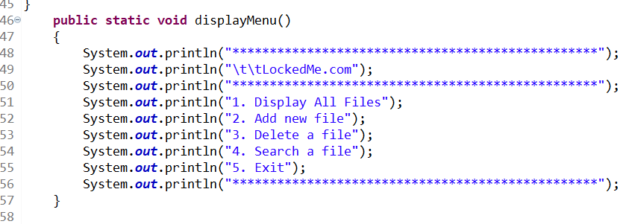

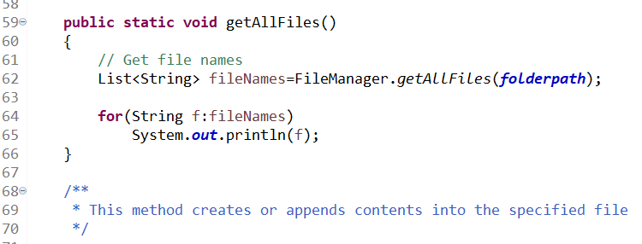

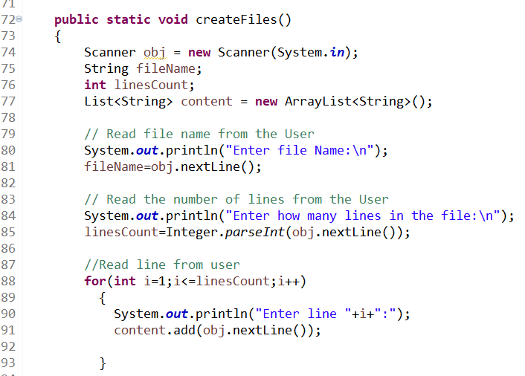

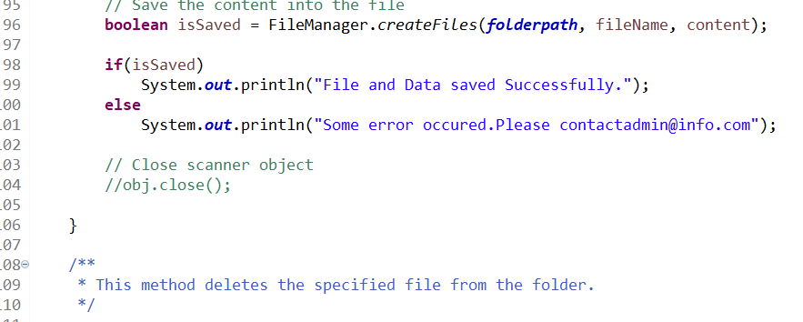

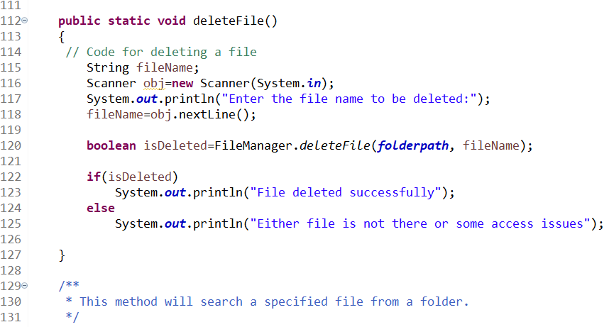

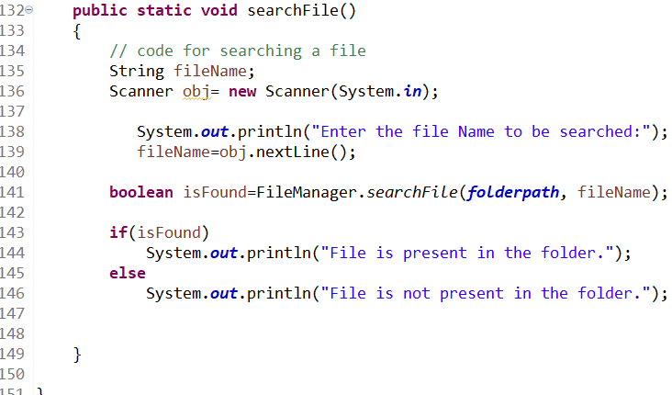

**FileManager.java:**

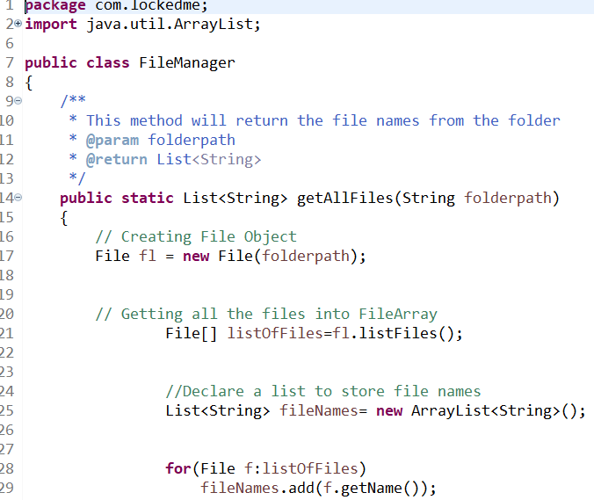

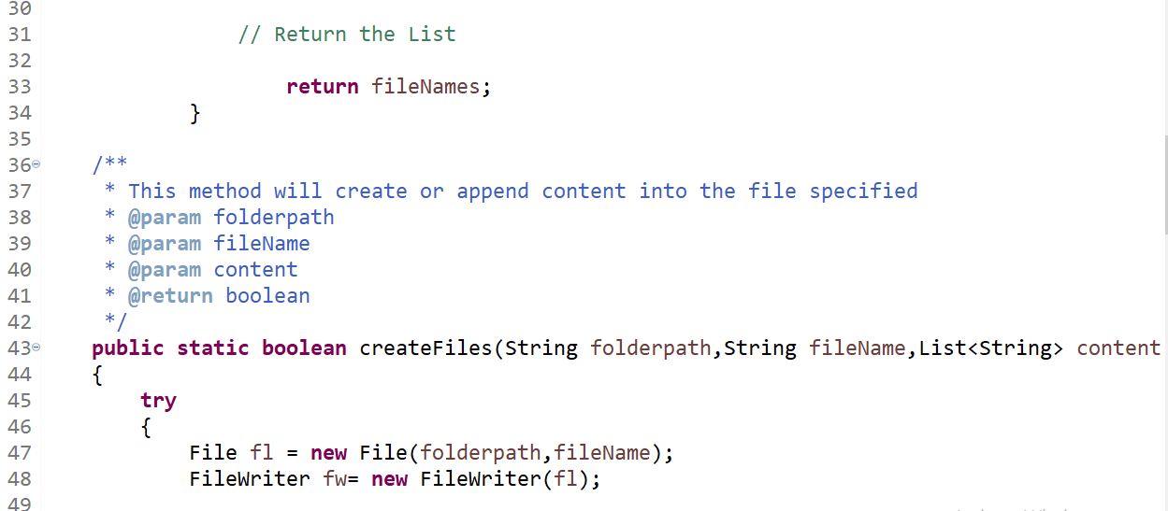

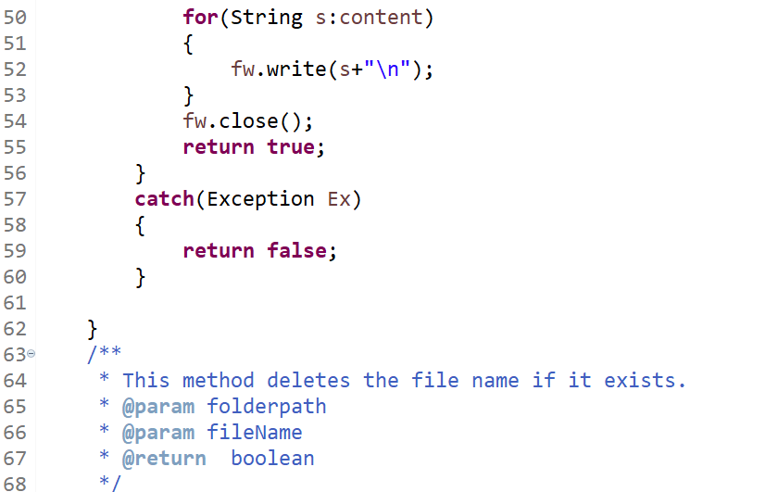

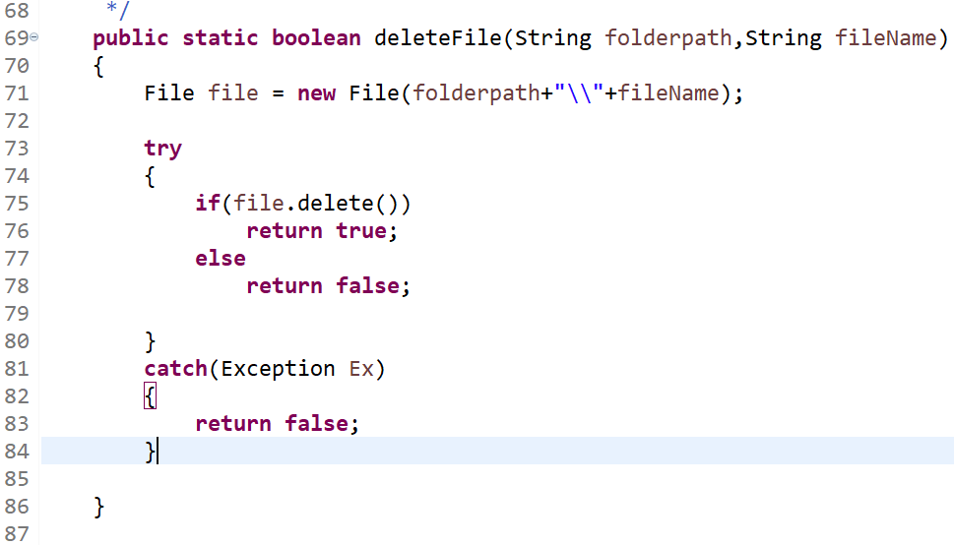

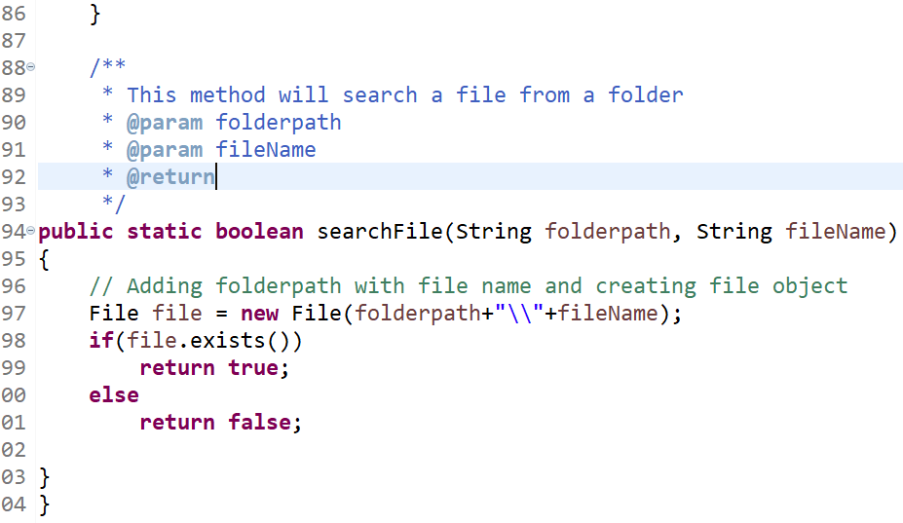

1. **Pushing the code to GitHub Repository:**

* Open your command prompt and navigate to the folder where you have created your files.

cd<folderpath>

* Initialize repository using the following command.

git init

* Add all the files to your git repository using the following command.

git commit –m <commit message>

* Push the files to the folder you initially created using the following

git push –u origin master

**Conclusions:**

* Conditions to check if user is allowed to delete the file or add the file in the directory.
* Asking user to verify if they really want to delete the selected directory if it’s not empty.
* Retrieving files/folders by different criteria like Last Modified, Type etc.
* Allowing user to append data to the file.